

Topic test 1
Name: __________________________________

Chapter 7: Rates of change

• Time allowed: 45 minutes
• CAS calculators may be used.
• Part A: 5 multiple-choice questions (5 marks)
• Part B: 5 short answer questions (22 marks)
• Part C: 2 analysis questions (14 marks)
Part A
5 multiple-choice questions
1 mark each: 5 marks
Circle the correct answer.
1 This graph shows the amount of water in a reservoir over time.
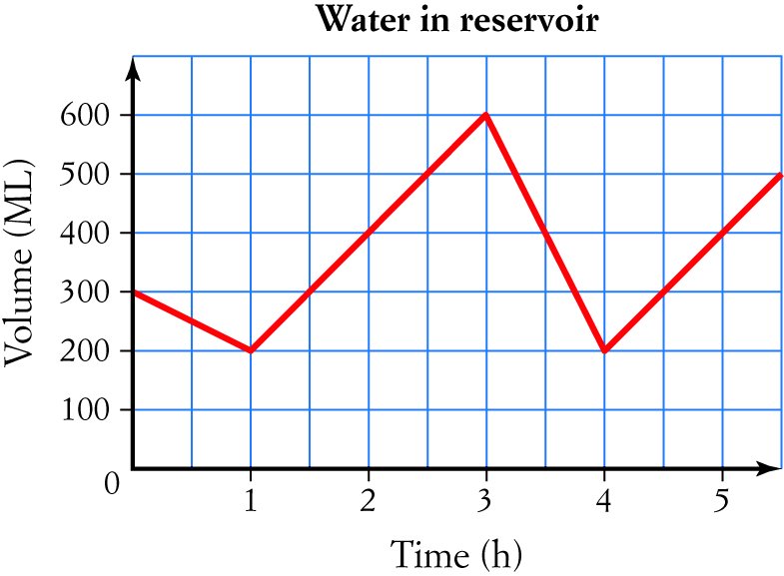
The average rate of change of the amount of water from 0 to 2 hours was:
A 150 ML/h
B 200 ML/h
C 50 ML/h
D 130 ML/h
E 100 ML/h

[1 mark]

2 From the graph in question 1, the instantaneous rate of change of the water level at 2 hours was:
A 150 ML/h
B 200 ML/h
C 50 ML/h
D 130 ML/h
E 100 ML/h

[1 mark]
3 A stone drops into deep water below a cliff that is 10.2 m above the water. The stone is travelling at a speed
of 14.8 m/s when it hits the water. After travelling 2.1 m down through the water in 0.15 seconds it has slowed
to 13.2 m/s. If the rate of change of the speed remains the same, how long after hitting the water will it be at
6.8 m/s?
A 0.75 s
B 0.6 s
C 1.6 s
D 1.07 s
E 0.9 s

[1 mark]
4 The diagram below shows the graph of a function.
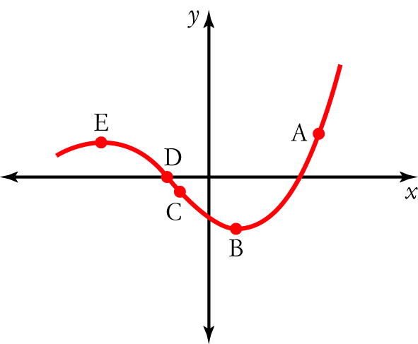
At which point on the graph is the rate of change the greatest?

[1 mark]

5 The rate of change of f(x) = x³ – 3x + 3 at x = 2 is approximately:
A 5
B 8
C 12
D 6
E 9

[1 mark]
Part B
5 short answer questions
22 marks
Show your working where appropriate.
1 In 2002 the price of a 250 L refrigerator was $429, but by 2012 the price of a comparable 250 L refrigerator had risen to $609. What was the average rate of price increase?

[2 marks]
2 The graph below shows the resistance of a platinum wire at different temperatures. Find the average rate of change of resistance between 200° and 600°.

[4 marks]

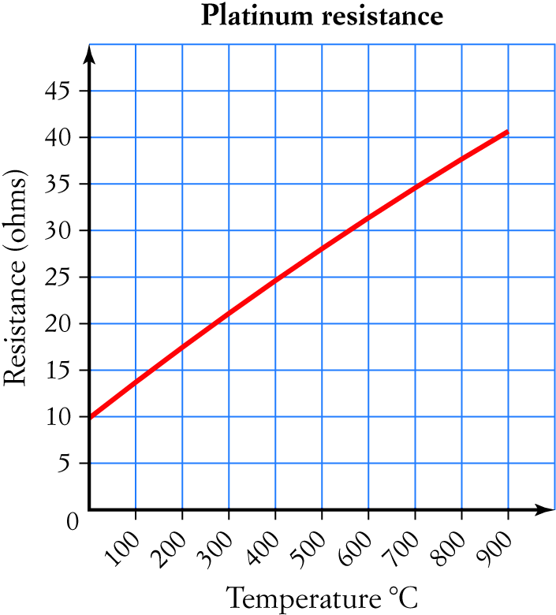

3 The graph below shows the solubility of potassium nitrate at different temperatures. Use a tangent to find the rate of change of the solubility at 30°C.
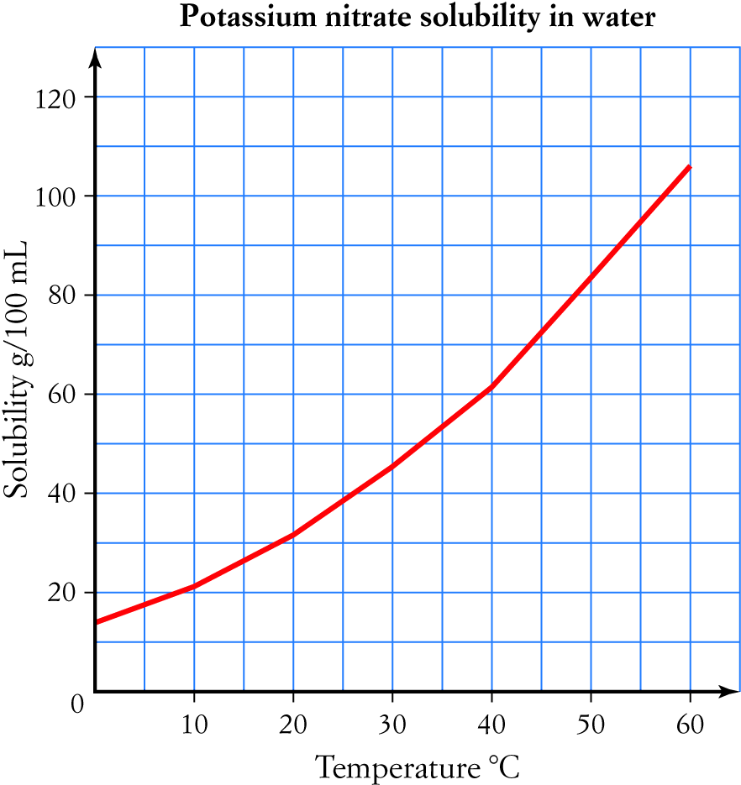

[7 marks]
4 Find the gradient of f(x) = 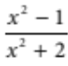 at x = 3 using a tangent (on your CAS calculator).

[4 marks]
5 Use δx = 0.06 to find the approximate gradient of y = x² – 5 at x = 2 using a secant around the point.

[5 marks]

Part C
2 analysis questions
14 marks
Show your working where appropriate.
1 Find approximate rates of change for the function f(x) = 5 – 2x² + x at values of x from 0 to 4 to suggest a function for the rate of change of f(x).

[7 marks]
2 Find approximate rates of change for the function f(x) = 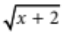 at values of x = –1, 2, 7 and 14 to suggest a function for the rate of change of f(x).

[7 marks]
Total marks: 41

Answers
Part A [1 mark each]
1 Average rate of change = 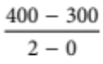 = 50 ML/h
∴ C [1 mark]
2 The line at 2 hours passes through (1, 200) and (2, 400), so the rate of change = 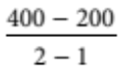 = 200 ML/h
∴ B [1 mark]
3 Rate of change of speed = 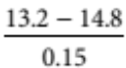 = 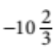 m/s/s
Desired change of speed = 6.8 – 14.8 = –8 m/s
Time for change = 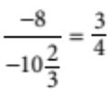 = 0.75 s
∴ A [1 mark]
4 The greatest rate of change is where the graph is steepest.
∴ A [1 mark]
5 Choosing δx = 0.2, rate of change ≈ 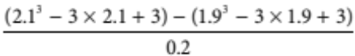 = 9.01
∴ E [1 mark]
Part B
1 Average rate of increase of the price = 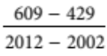 [1 mark]
= $18/year [1 mark]
[2 marks]
2 Resistance at 200°C = 17.5 ohm [1 mark]
Resistance at 600°C = 31.5 ohm [1 mark]
Rate of change of resistance = 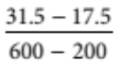 [1 mark]
= 0.035 ohm/°C [1 mark]
[4 marks]
3 Draw in a tangent at 30°C.
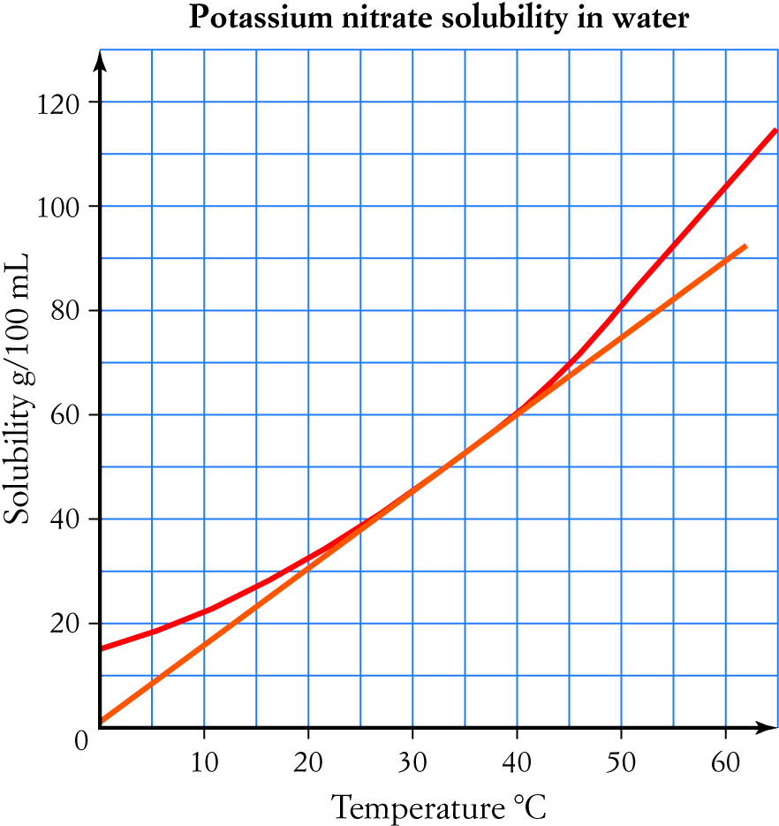
[2 marks for reasonably accurate tangent]
The tangent goes through (0, 0) and (50, 74). [1 mark each]
Rate of change of solubility = 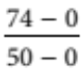 [1 mark]
≈ 1.5 g/100 mL/°C [1 mark for figure, 1 for units]
[7 marks]
4 Enter the function as a graph. [1 mark]
Use trace and zoom-in to put a point at (3, 0.727). [1 mark]
Draw a tangent and measure the slope to get 0.149. [2 marks]
[4 marks]
5 Calculate the values at 1.97 and 2.03 to get (1.97, –1.1191) and (2.03, –0.8791). [1 mark each]
Then δy = –0.8791 – (–1.1191) = 0.24 [1 mark]
So the gradient is 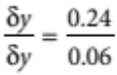 [1 mark]
= (approximately) 4 . [1 mark]
[5 marks]
Part C
Students are expected to use CAS calculators efficiently.
1 At x = 0, the approximate rate of change is 1. [1 mark]
At x = 1, the approximate rate of change is –3. [1 mark]
At x = 2, the approximate rate of change is –7. [1 mark]
At x = 3, the approximate rate of change is –11. [1 mark]
At x = 4, the approximate rate of change is –15. [1 mark]
This suggests that the function for the rate of change is y = 1 − 4x [2 marks]
[7 marks]
2 At x = –1, the approximate rate of change is 0.5 = [1 mark]
At x = 2, the approximate rate of change is 0.25 = [1 mark]
At x = 7, the approximate rate of change is 0.167 ≈ [1 mark]
At x = 14, the approximate rate of change is 0.125 = [1 mark]
The calculations all involved , and for –1, 2, 7 and 14 these are 1, 2, 3, and 4. [1 mark]
This suggests that the rate of change function is y = 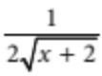 [2 marks]
[7 marks]

